EX NO:2 Use Image maps in Webpages
Date: /02/2026

Aim:

Procedure:

Program:
HTML:
<!DOCTYPE html>
<html lang="en">

<head>
<meta charset="UTF-8">
<meta name="viewport" content="width=device-width, initial-scale=1.0">
<title>Games I have played</title>
<link rel="stylesheet" href="style.css">
<link rel="stylesheet" href="animations.css">
</head>

<body>
<section class="game-section intro-section">
<img src="imgs/back.jpg" alt="" class="bg-image active">
<div class="intro-content">
<h1>Video Game Portfolio</h1>
</div>
<nav class="bookmarks">
<a href="#rdr2">Red Dead Redemption 2</a>
<a href="#got">Ghost of Tsushima</a>
<a href="#wd2">Watch Dogs 2</a>
<a href="#hd2">Helldivers 2</a>
<a href="#r6s">Rainbow Six Siege</a>
<a href="#wt">Warthunder</a>
<a href="#ao">Albion Online</a>
<a href="#mr">Marvel Rivals</a>
<a href="#so">Sea of Thieves</a>
<a href="#nms">No Man's Sky</a>
<a href="#bf5">Battlefield 5</a>
<a href="#aoe">Age of Empires</a>
</nav>
</section>
<section class="game-section" id="rdr2">
<div class="carousel-container">
<img src="imgs/rdr2 (2).png" class="bg-image active" alt="Red Dead Redemption II" data-screenshot="true">
<img src="imgs/rdr2 (3).png" class="bg-image" alt="Red Dead Redemption II" data-screenshot="true">
<img src="imgs/rdr2.png" class="bg-image" alt="Red Dead Redemption II" data-screenshot="true">
<img src="imgs/rdr2 (4).png" class="bg-image" alt="Red Dead Redemption II" data-screenshot="true">
<button class="carousel-btn prev" aria-label="Previous image">‹</button>
<button class="carousel-btn next" aria-label="Next image">›</button>
</div>
<div class="info-card info-card-right rdr2">
<div class="gametitle img rdr2img"><img src="imgs/rdr2logo.png" alt="Red Dead Redemption II"></div>
<ul class="stats">
<li><b>Hours Played:</b> 250+</li>
<li><b>My Rating:</b> 10/10</li>
<li><b>One liner:</b><br>The Best Story Game ever made.</li>
</ul>
</div>
</section>
<section class="game-section" id="got">
<div class="carousel-container">
<img src="imgs/got.png" class="bg-image active" alt="Ghost Of Tsushima" data-screenshot="true">
<img src="imgs/got (2).png" class="bg-image" alt="Ghost Of Tsushima" data-screenshot="true">
<img src="imgs/got .png" class="bg-image" alt="Ghost Of Tsushima" data-screenshot="true">
<button class="carousel-btn prev" aria-label="Previous image">‹</button>
<button class="carousel-btn next" aria-label="Next image">›</button>
</div>
<div class="info-card info-card-right got">
<div class="gametitle img gotimg"><img src="imgs/gotlogo2.png" alt="Ghost Of Tsushima"></div>
<ul class="stats">
<li><b>Hours Played:</b> 60+</li>
<li><b>My Rating:</b> 8/10</li>
<li><b>One liner:</b><br>A visually stunning journey of a samurai with fluid combat and emotional story
telling.</li>
</ul>
</div>
</section>
<section class="game-section" id="wd2">
<div class="carousel-container">
<img src="imgs/wd1.jpg" class="bg-image active" alt="Watch Dogs 2">
<img src="imgs/wd1 (2).jpg" class="bg-image" alt="Watch Dogs 2">
<img src="imgs/wd2.jpg" class="bg-image" alt="Watch Dogs 2">
<img src="imgs/wd2 (1).jpg" class="bg-image" alt="Watch Dogs 2" data-screenshot="true">
<img src="imgs/wd2 (2).jpg" class="bg-image" alt="Watch Dogs 2" data-screenshot="true">
<button class="carousel-btn prev" aria-label="Previous image">‹</button>
<button class="carousel-btn next" aria-label="Next image">›</button>
</div>
<div class="wd2 info-card info-card-left">
<div class="gametitle img wdimg"><img src="imgs/wdlogo (2).png" alt="Watch Dogs 2 logo"></div>
<ul class="stats">
<li><b>Hours Played:</b> 100+</li>
<li><b>My Rating:</b> 8/10</li>
<li><b>One liner:</b><br>An open-world action game where hacking is the core gameplay mechanic.</li>
</ul>
</div>
</section>
<section class="game-section" id="hd2">
<div class="carousel-container">
<img src="imgs/hd2.jpg" class="bg-image active" alt="Helldivers 2">
<img src="imgs/hd2.webp" class="bg-image" alt="Helldivers 2">
<img src="imgs/hd2 (3).webp" class="bg-image" alt="Helldivers 2">
<button class="carousel-btn prev" aria-label="Previous image">‹</button>
<button class="carousel-btn next" aria-label="Next image">›</button>
</div>
<div class="info-card info-card-left hd2">
<div class="gametitle img hd2img"><img src="imgs/hd2logo.png" alt="Helldivers 2 logo"></div>
<ul class="stats">
<li><b>Hours Played:</b> 200+</li>
<li><b>My Rating:</b> 8/10</li>
<li><b>One liner:</b><br>A PvE shooter where everyone has explosives and opinions.</li>
</ul>
</div>
</section>
<section class="game-section" id="r6s">
<div class="carousel-container">
<img src="imgs/r6 (2).jpg" class="bg-image active" alt="Rainbow six siege">
<img src="imgs/r6.jpg" class="bg-image" alt="Rainbow six siege">
<img src="imgs/r6 (3).jpg" class="bg-image" alt="Rainbow six siege">
<div class="video-player bg-image" data-screenshot="true">
<video id="r6Video" class="video" muted>
<source src="imgs/r62.mp4" type="video/mp4">
</video>
<div class="video-controls">
<button id="r6PlayPauseBtn" class="control-btn">▶ Play</button>
<button id="r6MuteBtn" class="control-btn">Unmute</button>
</div>
</div>
<button class="carousel-btn prev" aria-label="Previous image">‹</button>
<button class="carousel-btn next" aria-label="Next image">›</button>
</div>
<div class="info-card info-card-right r6s">
<div class="gametitle img r6simg"><img src="imgs/r6logo.png" alt="Rainbow six siege logo"></div>
<ul class="stats">
<li><b>Hours Played:</b> 75+</li>
<li><b>My Rating:</b> 8/10</li>
<li><b>One liner:</b><br>A tactical first-person shooter emphasizing destructible environments and
strategy.</li>
</ul>
</div>
</section>
<section class="game-section" id="wt">
<div class="carousel-container">
<img src="imgs/wt.webp" class="bg-image" alt="Warthunder">
<img src="imgs/wt.jpg" class="bg-image active" alt="Warthunder">
<button class="carousel-btn prev" aria-label="Previous image">‹</button>
<button class="carousel-btn next" aria-label="Next image">›</button>
</div>
<div class="info-card info-card-right wt">
<div class="gametitle img wtimg"><img src="imgs/wtlogo.png" alt="Warthunder logo"></div>
<ul class="stats">
<li><b>Hours Played:</b> 40+</li>
<li><b>My Rating:</b> 8/10</li>
<li><b>One liner:</b><br>A realistic combat simulator featuring detailed air, land, and naval warfare.
</li>
</ul>
</div>
</section>
<section class="game-section" id="ao">
<div class="carousel-container">
<img src="imgs/ao.jpg" class="bg-image active" alt="Albion Online">
<img src="imgs/ao.jpeg" class="bg-image" alt="Albion Online">
<img src="imgs/ao (2).jpg" class="bg-image" alt="Albion Online">
<button class="carousel-btn prev" aria-label="Previous image">‹</button>
<button class="carousel-btn next" aria-label="Next image">›</button>
</div>
<div class="info-card info-card-right ao">
<div class="gametitle img aoimg"><img src="imgs/aologo.png" alt="Albion Online logo"></div>
<ul class="stats">
<li><b>Hours Played:</b> 70+</li>
<li><b>My Rating:</b> 8/10</li>
<li><b>One liner:</b><br>A player-driven MMORPG built around freedom, economy, and risk-based PvP.</li>
</ul>
</div>
</section>
<section class="game-section" id="mr">
<div class="carousel-container">
<img src="imgs/mr.jpg" class="bg-image active" alt="Marvel Rivals">
<div class="video-player bg-image" data-screenshot="true">
<video id="myVideo" class="video" muted>
<source src="imgs/mrvid.mp4" type="video/mp4">
</video>
<div class="video-controls">
<button id="playPauseBtn" class="control-btn">▶ Play</button>
<button id="muteBtn" class="control-btn">Unmute</button>
</div>
</div>
<button class="carousel-btn prev" aria-label="Previous image">‹</button>
<button class="carousel-btn next" aria-label="Next image">›</button>
</div>
<div class="info-card info-card-right mr">
<div class="gametitle img mrimg"><img src="imgs/mrlogo.png" alt="Marvel Rivals logo"></div>
<ul class="stats">
<li><b>Hours Played:</b> 15+</li>
<li><b>My Rating:</b> 8/10</li>
<li><b>One liner:</b><br>Team-based shooter built around Marvel heroes and ability-driven combat.</li>
</ul>
</div>
</section>
<section class="game-section" id="so">
<div class="carousel-container">
<img src="imgs/sot.jpg" class="bg-image active" alt="Sea of Thieves">
<img src="imgs/sot.png" class="bg-image" alt="Sea of Thieves" data-screenshot="true">
<button class="carousel-btn prev" aria-label="Previous image">‹</button>
<button class="carousel-btn next" aria-label="Next image">›</button>
</div>
<div class="info-card info-card-right sot">
<div class="gametitle img sotimg"><img src="imgs/solelogo.png" alt="Sea of Thieves logo"></div>
<ul class="stats">
<li><b>Hours Played:</b> 20+</li>
<li><b>My Rating:</b> 8/10</li>
<li><b>One liner:</b><br>A shared-world pirate adventure focused on exploration and cooperative play
</li>
</ul>
</div>
</section>
<section class="game-section" id="nms">
<div class="carousel-container">
<img src="imgs/nms.png" class="bg-image active" alt="No Man's Sky">
<img src="imgs/nms (2).png" class="bg-image" alt="No Man's Sky" data-screenshot="true">
<button class="carousel-btn prev" aria-label="Previous image">‹</button>
<button class="carousel-btn next" aria-label="Next image">›</button>
</div>
<div class="info-card info-card-right nms">
<div class="gametitle img nmsimg"><img src="imgs/nmslogo.webp" alt="No Man's Sky logo"></div>
<ul class="stats">
<li><b>Hours Played:</b>40+</li>
<li><b>My Rating:</b> 8/10</li>
<li><b>One liner:</b><br>An open-world space exploration game with procedurally generated galaxies.</li>
</ul>
</div>
</section>
<section class="game-section" id="bf5">
<div class="carousel-container">
<img src="imgs/bf5 (2).jpg" class="bg-image active" alt="Battlefield 5">
<img src="imgs/bf5.webp" class="bg-image" alt="Battlefield 5">
<button class="carousel-btn prev" aria-label="Previous image">‹</button>
<button class="carousel-btn next" aria-label="Next image">›</button>
</div>
<div class="info-card info-card-right bf5">
<div class="gametitle img bf5img"><img src="imgs/bf5 logo.png" alt="Battlefield 5 logo"></div>
<ul class="stats">
<li><b>Hours Played:</b> 70+</li>
<li><b>My Rating:</b> 8/10</li>
<li><b>One liner:</b><br>A large-scale multiplayer shooter set during World War II with vehicle combat
and destructible environments.</li>
</ul>
</div>
</section>
<section class="game-section" id="aoe">
<div class="carousel-container">
<img src="imgs/aoe.jpg" class="bg-image active" alt="Age of Empires">
<img src="imgs/aoe.png" class="bg-image" alt="Age of Empires" data-screenshot="true">
<img src="imgs/aoe.webp" class="bg-image" alt="Age of Empires">
<button class="carousel-btn prev" aria-label="Previous image">‹</button>
<button class="carousel-btn next" aria-label="Next image">›</button>
</div>
<div class="info-card info-card-right aoe">
<div class="gametitle img aoeimg"><img src="imgs/aoelogo.png" alt="Age of Empires logo"></div>
<ul class="stats">
<li><b>Hours Played:</b>280+</li>
<li><b>My Rating:</b> 9/10</li>
<li><b>One liner:</b><br>A classic strategy game that sharpens resource management and tactical
thinking.</li>
</ul>
</div>
</section>
<script src="script.js"></script>
</body>
</html>

CSS:

body,
html {
margin: 0;
padding: 0;
font-family: 'Segoe UI', Tahoma, Geneva, Verdana, sans-serif;
color: white;
background-color: #111;
scroll-snap-type: y mandatory;
overflow-y: scroll;
height: 100vh;
scroll-behavior: smooth;
}
.game-section {
position: relative;
height: 100vh;
display: flex;
align-items: center;
overflow: hidden;
scroll-snap-align: center;
}
.intro-section {
justify-content: center;
align-items: center;
position: relative;
background-color: #000;
}
.intro-content {
position: absolute;
top: 55%;
left: 50%;
transform: translate(-50%, -50%);
z-index: 3;
text-align: center;
}
.intro-content h1 {
font-size: 3.5rem;
font-weight: 700;
margin: 0;
color: #fff;
text-transform: uppercase;
letter-spacing: 10px;
font-family: 'Courier New', monospace;
margin-bottom: 500px;
}
.bookmarks {
position: absolute;
width: 100%;
height: 100%;
top: 0;
left: 0;
z-index: 2;
}
.bookmarks a {
position: absolute;
color: #fff;
text-decoration: none;
font-size: 0.85rem;
font-weight: 500;
padding: 10px 20px;
border: 2px solid rgba(255, 255, 255, 0.7);
background: rgba(0, 0, 0, 0.8);
transition: all 0.3s ease;
text-transform: uppercase;
letter-spacing: 2px;
font-family: 'Courier New', monospace;
white-space: nowrap;
}
.bookmarks a:nth-child(1) {
top: 8%;
left: 5%;
}
.bookmarks a:nth-child(2) {
top: 8%;
right: 5%;
}
.bookmarks a:nth-child(3) {
top: 25%;
left: 3%;
}
.bookmarks a:nth-child(4) {
top: 25%;
right: 3%;
}
.bookmarks a:nth-child(5) {
bottom: 25%;
left: 3%;
}
.bookmarks a:nth-child(6) {
bottom: 25%;
right: 3%;
}
.bookmarks a:nth-child(7) {
bottom: 8%;
left: 5%;
}
.bookmarks a:nth-child(8) {
bottom: 8%;
right: 5%;
}
.bookmarks a:nth-child(9) {
top: 50%;
left: 2%;
transform: translateY(-50%);
}
.bookmarks a:nth-child(10) {
top: 50%;
right: 2%;
transform: translateY(-50%);
}
.bookmarks a:nth-child(11) {
bottom: 8%;
left: 50%;
transform: translateX(-50%);
}
.bookmarks a:nth-child(12) {
top: 8%;
left: 50%;
transform: translateX(-50%);
}
.bookmarks a:hover {
background: rgba(255, 255, 255, 0.2);
border-color: rgba(255, 255, 255, 1);
}

.bookmarks a:active {
transform: scale(1.02);
}
.carousel-container {
position: absolute;
top: 0;
left: 0;
width: 100%;
height: 100%;
z-index: 0;
}
.bg-image {
position: absolute;
top: 0;
left: 0;
width: 100%;
height: 100%;
object-fit: cover;
z-index: 0;
filter: brightness(0.8);
opacity: 0;
transition: opacity 0.6s ease-in-out;
}
.bg-image.active {
opacity: 1;
}
.screenshot-tooltip {
position: absolute;
bottom: 10px;
left: 50%;
transform: translateX(-50%);
color: rgb(206, 206, 206);
padding: 6px 12px;
border-radius: 6px;
font-size: 12px;
font-weight: 500;
white-space: nowrap;
opacity: 0;
pointer-events: none;
transition: opacity 0.3s ease;
z-index: 100;
border: 1px solid rgba(255, 255, 255, 0.3);
}

.screenshot-tooltip.show {
opacity: 1;
}

.carousel-btn {
position: absolute;
bottom: 30px;
background: rgba(255, 255, 255, 0.1);
border: 2px solid rgba(255, 255, 255, 0.3);
color: white;
font-size: 1.5rem;
width: 40px;
height: 40px;
border-radius: 50%;
cursor: pointer;
z-index: 10;
backdrop-filter: blur(10px);
transition: all 0.3s ease;
display: flex;
align-items: center;
justify-content: center;
padding: 0;
line-height: 1;
}

.carousel-btn:hover {
background: rgba(255, 255, 255, 0.3);
border-color: rgba(255, 255, 255, 0.6);
transform: scale(1.1);
box-shadow: 0 0 20px rgba(255, 255, 255, 0.4);
}

.carousel-btn.prev {
left: 30px;
}

.carousel-btn.next {
left: 80px;
}

.info-card {
width: 30%;
min-width: auto;
padding: 20px;
backdrop-filter: blur(10px);
box-shadow: 0 0 30px rgba(0, 0, 0, 0.5);
z-index: 1;
}

.info-card-right {
margin-left: auto;
margin-right: 5%;
}

.info-card-left {
margin-right: auto;
margin-left: 5%;
}

.rdr2 {
backdrop-filter: blur(5px) brightness(0.5);
align-self: flex-end;
margin-bottom: 400px;
color: #e20526;
}

.got {
backdrop-filter: blur(3px);
align-self: flex-end;
margin-bottom: 100px;
color: #d2c188;
}

.wd2 {
backdrop-filter: blur(3px) brightness(0.6);
align-self: flex-end;
margin-bottom: 100px;
color: #00ff22;
}

.hd2 {
backdrop-filter: blur(3px) brightness(0.6);
align-self: flex-end;
margin-bottom: 150px;
color: #ffb400;
}

.r6s {
backdrop-filter: blur(5px) brightness(0.7);
align-self: flex-end;
margin-bottom: 340px;
color: #0042d1;
}

.wt {
backdrop-filter: blur(5px) brightness(0.7);
align-self: flex-end;
margin-bottom: 20px;
color: #fd8b20;
}

.ao {
backdrop-filter: blur(5px) brightness(0.7);
align-self: flex-end;
margin-bottom: 80px;
color: #fd2020;
}

.mr {
backdrop-filter: blur(5px) brightness(0.45);
align-self: flex-end;
margin-bottom: 80px;
color: #ed1a23;
}

.sot {
backdrop-filter: blur(5px) brightness(0.45);
align-self: flex-end;
margin-bottom: 80px;
color: #d2c188;
}

.nms {
backdrop-filter: blur(5px) brightness(0.45);
align-self: flex-end;
margin-bottom: 400px;
color: #e90404;
}

.bf5 {
backdrop-filter: blur(5px) brightness(0.45);
align-self: flex-end;
margin-bottom: 340px;
color: #8abdf8;
}

.aoe {
backdrop-filter: blur(5px) brightness(0.45);
align-self: flex-end;
margin-bottom: 100px;
color: #ae3431;
}

.rdr2img {
width: 190%;
height: auto;
display: block;
}

.gotimg {
width: 180%;
height: auto;
display: block;
}

.wdimg {
width: 120%;
height: auto;
display: block;
}

.hd2img {
width: 180%;
height: auto;
display: block;
}

.r6simg {
width: 180%;
height: auto;
display: block;
}

.wtimg {
width: 130%;
height: auto;
display: block;
}

.aoimg {
width: 120%;
height: auto;
display: block;
}

.mrimg {
width: 130%;
height: auto;
display: block;
}

.sotimg {
width: 200%;
height: auto;
display: block;
}

.nmsimg {
width: 180%;
height: auto;
display: block;
align-items: center;
}

.gametitle img {
width: 50%;
height: auto;
display: block;
}

.bf5img {
width: 180%;
height: auto;
display: block;
}

.aoeimg {
width: 180%;
height: auto;
display: block;
}

.video-player {
position: absolute;
top: 0;
left: 0;
width: 100%;
height: 100%;
z-index: 0;
opacity: 0;
transition: opacity 0.6s ease-in-out;
}

.video-player.active {
opacity: 1;
}

.video-player .video {
width: 100%;
height: 100%;
object-fit: cover;
filter: brightness(0.8);
}

.video-controls {
position: absolute;
bottom: 80px;
left: 50%;
transform: translateX(-50%);
display: flex;
gap: 10px;
z-index: 11;
}

.control-btn {
padding: 10px 20px;
background: rgba(0, 0, 0, 0.8);
border: 2px solid rgba(255, 255, 255, 0.6);
color: #fff;
cursor: pointer;
font-size: 14px;
font-weight: 500;
text-transform: uppercase;
letter-spacing: 1px;
transition: all 0.3s ease;
backdrop-filter: blur(10px);
}

.control-btn:hover {
background: rgba(255, 255, 255, 0.2);
border-color: rgba(255, 255, 255, 1);
}

h2 {
font-size: 2.5rem;
margin-top: 0;
color: #00d4ff;
}

.stats {
list-style: none;
padding: 0;
line-height: 2;
}

.stats li b {
color: #b4b4b4;
text-transform: uppercase;
font-size: 1rem;
}

@media (max-width: 768px) {
.game-section {
justify-content: center;
}

.info-card {
width: 80%;
margin-right: 0;
}

.intro-content h1 {
font-size: 2rem;
letter-spacing: 4px;
}

.bookmarks a {
font-size: 0.7rem;
padding: 8px 15px;
letter-spacing: 1px;
}

.bookmarks a:nth-child(1) {
top: 10%;
left: 5%;
}

.bookmarks a:nth-child(2) {
top: 18%;
right: 5%;
}

.bookmarks a:nth-child(3) {
top: 26%;
left: 5%;
}

.bookmarks a:nth-child(4) {
top: 34%;
right: 5%;
}

.bookmarks a:nth-child(5) {
top: 42%;
left: 5%;
}

.bookmarks a:nth-child(6) {
top: 58%;
right: 5%;
}

.bookmarks a:nth-child(7) {
top: 66%;
left: 5%;
}

.bookmarks a:nth-child(8) {
top: 74%;
right: 5%;
}

.bookmarks a:nth-child(9) {
top: 82%;
left: 5%;
}

.bookmarks a:nth-child(10) {
bottom: 5%;
right: 5%;
}
}

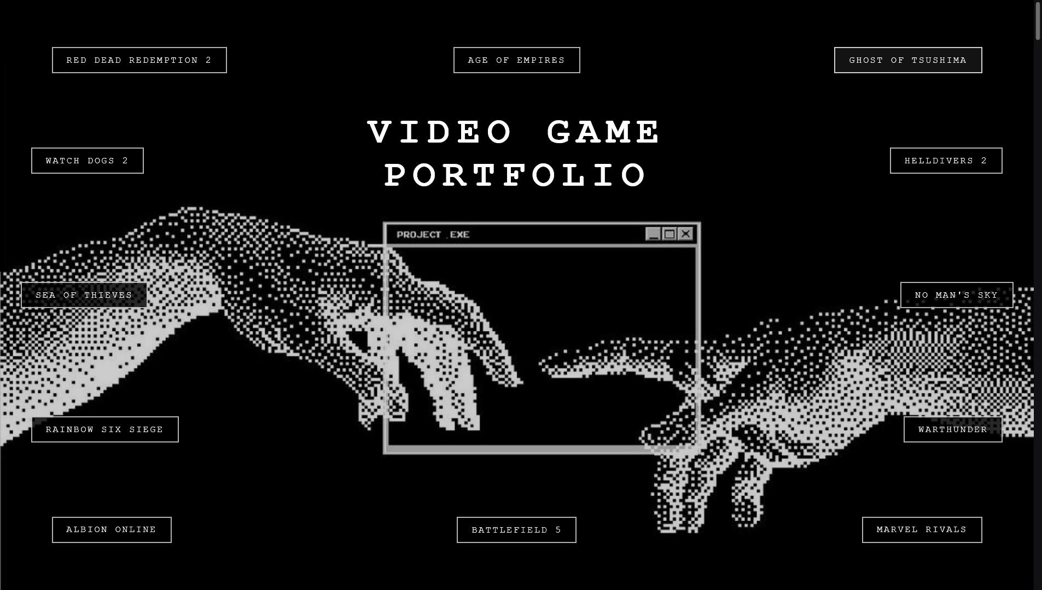
Output:

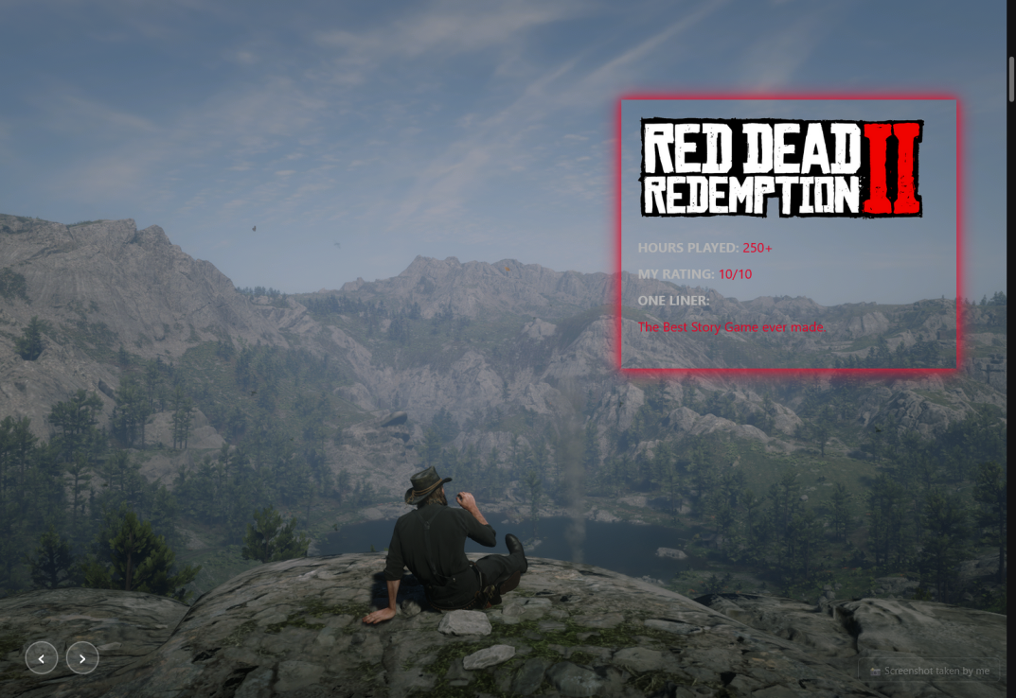

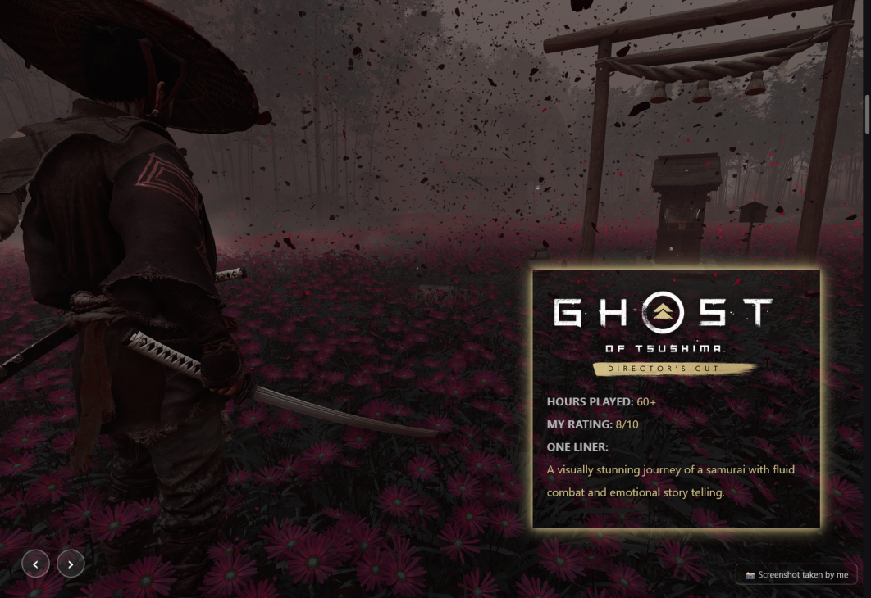

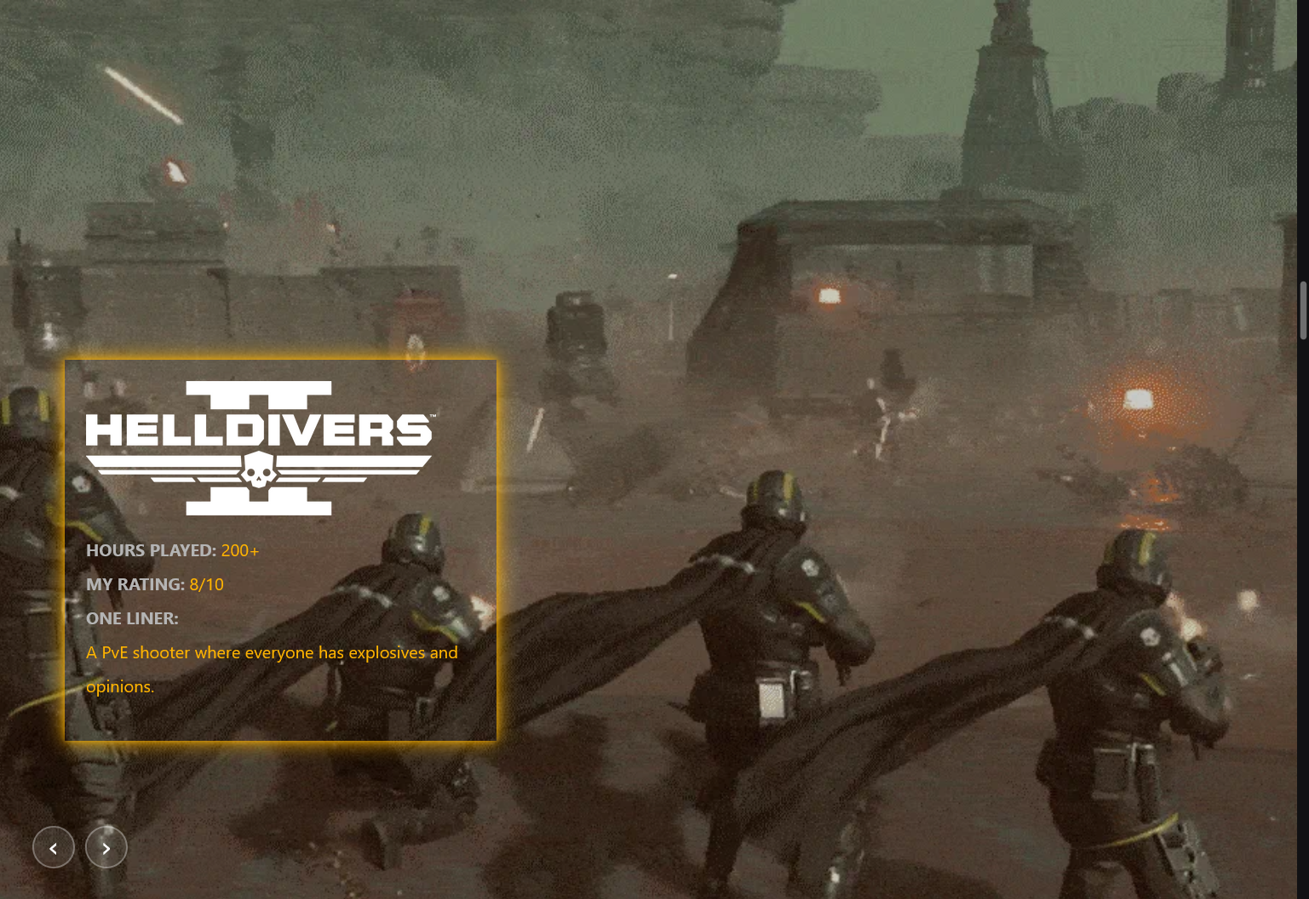

Result:

